TIMELESS MOMENTS-WHERE STORIES BEGIN

### A Mini Project Report submitted to

**MOHAN BABU UNIVERSITY**

### in Partial Fulfillment of the Requirements for the Award of the degree of

**BACHELOR OF TECHNOLOGY IN**

### COMPUTER SCIENCE AND ENGINEERING (CYBER SECURITY)

*Submitted by*

|  |  |
| --- | --- |
| **G. DIVYA YOSHITA** | **(23102A020089)** |
| **K. VENKAY YADAV** | **(23102A020055)** |
| **G. VIVEK** | **(23102A020066)** |

*Under the Guidance of*

### Mr. P. Yogendra Prasad

Assistant Professor

Department of Data Science



**Department of Data Science**

**SCHOOL OF COMPUTING**

**MOHAN BABU UNIVERSITY**

Sree Sainath Nagar, Tirupati – 517 102, A.P., INDIA

2025-26

**MOHAN BABU UNIVERSITY**

Sree Sainath Nagar, Tirupati – 517 102, A.P., INDIA

2025-26

**DEPARTMENT OF DATA SCIENCE**

CERTIFICATE

This is to certify that the mini project report entitled

**“TIMELESS MOMENTS-WHERE STORIES BEGIN”**

is the Bonafide work done by

|  |  |
| --- | --- |
| **G. DIVYA YOSHITA** | **(23102A020089)** |
| **K. VENKAT YADAV** | **(23102A020055)** |
| **G. VIVEK** | **(23102A020066)** |

in the Department of **Data Science**, and submitted to Mohan Babu University, Tirupati in partial fulfillment of the requirements for the award of the degree of Bachelor of Technology in Computer Science and Engineering (Cyber security) during the academic year 2025-2026. This work has been carried out under my supervision. The results of this mini project work have not been submitted to any university for the award of any degree or diploma.

***Guide: Head:***

Mr. P. Yogendra Prasad Dr. K. Redddy Madhavi

Assistant Professor Professor & Head

Dept. of Data Science Dept. of Data Science

**INTERNAL EXAMINER EXTERNAL EXAMINER**

**DEPARTMENT OF DATA SCIENCE**

**Vision**

To become a Centre of Excellence in Data Science by imparting high quality education through teaching, training and research

**Mission**

* To impart quality education in Computer Science and Engineering with specializations in Data Science by disseminating knowledge through contemporary curriculum, competent faculty and effective teaching-learning methodologies.
* Nurture research, innovation and entrepreneurial skills among students and faculty to contribute to the needs of industry and society.
* Inculcate professional attitude, ethical and social responsibilities for prospective and promising Engineering profession.
* Encourage students to engage in life-long learning by creating awareness of the contemporary developments in Computer Science and Engineering with specialization in Data Science.

**PROGRAM EDUCATIONAL OBJECTIVES**

After few years of graduation, the graduates of B. Tech. CSE(CS) will:

|  |  |
| --- | --- |
| **PEO1.** | Pursue higher studies in Computer Science, Data science or Management. |
| **PEO2.** | Become successful entrepreneurs or be employed by acquiring required skill sets in the domains of Data Science and allied areas. |
| **PEO3.** | Exhibit progression and effective adaptation to technological developments through life-long learning to address ever changing industrial requirements and follow ethical attitude in professional practice. |

**PROGRAM SPECIFIC OUTCOMES**

On successful completion of the Program, the graduates of B. Tech. CSE(CS) program will be able to:

|  |  |
| --- | --- |
| **PSO1.** | Apply appropriate data analytical techniques for building effective decision-making systems. |
| **PSO2.** | Develop intelligent systems using novel Machine Learning and Artificial Intelligence techniques. |
| **PSO3.** | Design and develop efficient software systems using modern tools, techniques, and platforms to meet societal needs. |
| **PSO4.** | Apply suitable tools and techniques to build secure distributed systems. |

**PROGRAM OUTCOMES**

On successful completion of the Program, the graduates of B.Tech. CSE (CS) Program will be able to:

|  |  |
| --- | --- |
| **PO1.** | **Engineering knowledge**: Apply the knowledge of mathematics, science, engineering fundamentals, and an engineering specialization to the solution of complex engineering problems. |
| **PO2.** | **Problem analysis**: Identify, formulate, review research literature, and analyze complex engineering problems reaching substantiated conclusions using first principles of mathematics, natural sciences, and engineering sciences. |
| **PO3.** | **Design/development of solutions**: Design solutions for complex engineering problems and design system components or processes that meet the specified needs with appropriate consideration for the public health and safety, and the cultural, societal, and environmental considerations. |
| **PO4.** | **Conduct investigations of complex problems**: Use research-based knowledge and research methods including design of experiments, analysis and interpretation of data, and synthesis of the information to provide valid conclusions. |
| **PO5.** | **Modern tool usage**: Create, select, and apply appropriate techniques, resources, and modern engineering and IT tools including prediction and modeling to complex engineering activities with an understanding of the limitations. |
| **PO6.** | **The engineer and society**: Apply reasoning informed by the contextual knowledge to assess societal, health, safety, legal and cultural issues and the consequent responsibilities relevant to the professional engineering practice. |
| **PO7.** | **Environment and sustainability**: Understand the impact of the professional engineering solutions in societal and environmental contexts, and demonstrate the knowledge of, and need for sustainable development. |
| **PO8.** | **Ethics**: Apply ethical principles and commit to professional ethics and responsibilities and norms of the engineering practice. |
| **PO9.** | **Individual and team work**: Function effectively as an individual, and as a member or leader in diverse teams, and in multidisciplinary settings. |
| **PO10.** | **Communication**: Communicate effectively on complex engineering activities with the engineering community and with society at large, such as, being able to comprehend and write effective reports and design documentation, make effective presentations, and give and receive clear instructions. |
| **PO11.** | **Project management and finance**: Demonstrate knowledge and understanding of the engineering and management principles and apply these to one’s own work, as a member and leader in a team, to manage projects and in multidisciplinary environments. |
| **PO12.** | **Life-long learning**: Recognize the need for, and have the preparation and ability to engage in independent and life-long learning in the broadest context of technological change. |

# DECLARATION

We hereby declare that this project report titled **"**TIMELESS MOMENTS-WHERE STORIES BEGIN**."** is a genuine work carried out by us in the [B.Tech](https://b.tech/) (Computer Science and Engineering(Cyber Security) degree course of our university and has not been submitted to any other course or University for the award of any degree by us.

We declare that this written submission represents our ideas in our own words and where others' ideas or words have been included, we have adequately cited and referenced the original sources. We also declare that we have adhered to all principles of academic honesty and integrity and have not misrepresented or fabricated or falsified any idea/data/fact/source in our submission. We understand that any violation of the above will cause for disciplinary action by the Institute and can also evoke penal action from the sources which have not been properly cited or from whom proper permission has not been taken when needed.

Signature of the students 1.

2.

3.

## ABSTRACT

Timeless Moments is a comprehensive event management platform designed to bridge the gap between customers seeking event services and professional vendors across all event categories. Built using modern web technologies including HTML, CSS, and JavaScript, we developed a robust multi-role system that serves diverse event planning needs throughout the evolving event services market. The platform addresses the critical need for efficient vendor discovery and event service booking across various event types and service categories.

Our platform features three distinct user interfaces with specialized dashboards for Customers, Vendors, and Administrators. Customers benefit from comprehensive service browsing across multiple categories including venues, photography, catering, entertainment, and decoration, with location-based filtering and personalized vendor recommendations. Vendors gain access to powerful tools for creating service listings with dynamic pricing packages, managing booking requests, communicating with customers, and tracking business performance through integrated analytics.

The technical architecture incorporates sophisticated features including real-time messaging systems, booking management workflows, secure role-based authentication, and comprehensive localStorage data management. The responsive design framework ensures optimal user experience across all devices, while the modular component-based structure enables seamless interactions and efficient workflow management for all user roles.

Timeless Moments demonstrates effective implementation of complete event service lifecycle management, from initial vendor discovery and service inquiry through booking confirmation, event execution, and post-event feedback. The platform represents a significant step forward in digital event planning solutions, providing scalable, accessible, and efficient connections between customers and quality event service providers in today's dynamic events industry.

**Keywords:** Event management, vendor marketplace, booking system, responsive design, HTML, CSS, JavaScript, multi-role platform, customer-vendor connectivity.

i

## TABLE OF CONTENTS

|  |  |
| --- | --- |
| **Title** | **Page No.** |
| ABSTRACT | i |
| **CHAPTER 1: INTRODUCTION** |  |
| 1.1 INTRODUCTION | 2 |
| 1.2 STATEMENT OF THE PROBLEM | 3 |
| 1.3 OBJECTIVES | 4 |
| 1.4 LIMITATIONS | 5 |
| **CHAPTER 2: METHODOLOGY** | 6-7 |
| **CHAPTER 3: DESIGN** |  |
| 3.1 REQUIREMENTS | 8 |
| 3.2 SYSTEM DESIGN | 9 |
| 3.3 TECHNOLOGIES USED | 10 |
| **CHAPTER 4: IMPLEMENTATION** | 11-12 |
| **CHAPTER: 5 PROPOSED SYSTEM ARCHITECTURE** |  |
| 5.1 FLOW CHART | 13-15 |
| **CHAPTER 6: CODING AND RESULT** |  |
| 6.1 CODE | 16-28 |
| 6.2 RESULT | 29-35 |
| **CHAPTER 7: CONCLUSION AND FUTURE WORK** |  |
| 7.1 CONCLUSION | 36 |
| 7.2 FUTURE WORK | 36-37 |

**CHAPTER- 1 INTRODUCTION**

### Introduction:

The design and development of Timeless Moments, a comprehensive event management platform built using modern web technologies to connect customers with professional event service vendors across diverse service categories. The primary objective of this platform is to bridge the gap between event planning needs and quality service providers by providing a robust, user-friendly ecosystem that serves the complete event management lifecycle.

At Timeless Moments, we understand that successful events extend beyond mere service booking. It involves creating memorable experiences, ensuring seamless coordination, and building trust between customers and vendors. That's why we've developed a multi-faceted platform that caters to various event needs – from weddings and corporate events to birthdays and social gatherings – ensuring that every customer can find suitable services and every vendor can showcase their expertise to potential clients.

Our platform provides comprehensive functionality for each user role: customers can explore diverse event services with advanced filtering capabilities, vendors can manage complete service portfolios and booking processes, and administrators can oversee platform operations and maintain service quality standards. Whether users are seeking venue bookings, photography services, catering, entertainment, or decoration services, Timeless Moments offers the tools and resources needed to facilitate successful event planning.

Our goal is to make the event planning process efficient and transparent by providing essential tools for vendor discovery, booking management, customer-vendor communication, and service coordination. We believe that the better the connection between customers and vendors, the more successful and memorable the events will be, ultimately contributing to the growth and professionalization of the event services industry.

### Problem Statement:

The current event services market faces significant challenges in efficiently connecting customers with reliable and professional event service vendors across diverse service categories. The fragmentation of service platforms creates difficulties for both customers seeking event services and vendors in establishing their presence, particularly when dealing with comprehensive event planning that requires multiple service types. This fragmentation hinders customers' ability to find quality services and vendors' capacity to reach potential clients effectively.

There exists a critical need for a unified, user-friendly platform that provides comprehensive event management solutions across all service domains - from venue booking and photography to catering, entertainment, and decoration services. Such a platform must address the unique requirements of different user groups while maintaining accessibility, reliability, and scalability for all event types and sizes.

During the development of Timeless Moments, we encountered several technical challenges including implementing secure multi-role authentication, managing real-time data synchronization across customer and vendor dashboards, integrating comprehensive booking and payment systems, and ensuring seamless user experience across various devices and screen sizes. Additional challenges included developing effective communication systems between customers and vendors, implementing robust notification systems for booking updates, and creating intuitive workflow management for complete event service lifecycle tracking.

The absence of such comprehensive platforms in the current market creates barriers to efficient vendor discovery, transparent booking processes, and reliable service coordination, ultimately affecting both customer satisfaction and vendor business growth in the event services industry.

### Objectives:

The main objective of the Timeless Moments project is to provide a unified platform that connects customers and event service vendors across all service categories and facilitates seamless event planning through the complete service lifecycle. The specific objectives are:

* **Centralize Event Services**: Create a single platform aggregating service listings and vendor profiles across diverse event categories including venues, photography, catering, entertainment, decoration, and specialized event services
* **Enhance Accessibility**: Develop an intuitive, user-friendly interface accessible to customers and vendors across different technical proficiencies, ensuring easy navigation and service discovery
* **Provide Comprehensive Event Solutions**: Implement complete workflow management from vendor discovery and service inquiry through booking confirmation, event execution, and post-event feedback
* **Promote Diverse Service Categories**: Ensure equal platform access for all event service types, from large venue providers to individual photographers and specialized service vendors
* **Ensure Responsive Design**: Create a fully responsive interface that delivers optimal user experience across all devices - desktop, tablet, and mobile
* **Facilitate Secure Bookings**: Implement robust booking management systems with clear communication channels and status tracking to ensure reliability for both customers and vendors
* **Enable Efficient Service Matching**: Develop advanced search and filtering capabilities based on service categories, location, pricing, availability, customer ratings, and other relevant parameters
* **Support Vendor Business Growth**: Provide vendors with tools to showcase their services, manage bookings, communicate with customers, and build their reputation through reviews and ratings
* **Streamline Customer Experience**: Offer customers a seamless process for discovering, comparing, and booking event services with transparent pricing and vendor information

### Limitations:

The development and implementation of the Timeless Moments platform encountered several limitations:

* **Limited Initial Vendor Base**: As a new platform, Timeless Moments faces challenges in achieving critical mass of both customers and quality-verified vendors across all service categories and geographic regions during initial rollout
* **Data Scalability Constraints**: The current localStorage implementation, while effective for prototype development, presents limitations in handling large-scale user data, concurrent bookings, and complex service matching operations required for full commercial deployment
* **Payment System Integration**: The platform currently utilizes a simulated payment system, with full integration of real payment gateways, booking deposits, and secure transaction processing remaining for future implementation
* **Geographic Coverage Limitations**: While designed for comprehensive service coverage, initial implementation has focused on specific regions, with nationwide vendor onboarding and location-based service matching requiring further expansion
* **Mobile Application Gap**: The current web-based responsive design, while mobile-friendly, lacks dedicated native mobile applications for iOS and Android platforms that could enhance user engagement and on-the-go booking management
* **Advanced Feature Constraints**: Certain advanced features such as AI-based vendor recommendations, real-time availability tracking, video consultations, and sophisticated analytics dashboards for vendors remain earmarked for future development phases
* **Verification System Scope**: The current vendor verification system handles basic validation, with comprehensive background checks, portfolio verification, and quality assurance processes requiring additional development and third-party integrations
* **Real-time Communication Limits**: While basic messaging is implemented, advanced real-time features like video calls, file sharing, and collaborative event planning tools require further development for seamless customer-vendor coordination
* **Service Capacity Management**: The current system has limitations in handling complex vendor scheduling, capacity management, and conflict resolution for overlapping bookings across multiple service providers

## CHAPTER – 2 METHODOLOGY

The development of Timeless Moments followed a **pure vanilla web development methodology** without any external frameworks or libraries.

**3.2.1 Core Development Approach**

**Native Technology Implementation**

* Used **pure** HTML5 for semantic structure and accessibility
* Implemented vanilla CSS3 with custom Grid and Flexbox layouts
* Developed with native JavaScript  without any frameworks
* Utilized browser-native APIs for all functionality

**Component Architecture**

* Built custom UI components from scratch using vanilla JavaScript
* Created modular CSS with custom variables and reusable classes
* Implemented manual DOM manipulation for dynamic content
* Developed custom event handling systems

**Data Management Strategy**

* Used native localStorage API for client-side data persistence
* Implemented custom data validation without external libraries
* Created manual form handling and processing logic
* Built custom state management using plain JavaScript objects

**3.2.2 Development Workflow**

**Progressive Enhancement Approach**

* Started with basic HTML structure for all pages
* Enhanced with progressive CSSstyling layers
* Added interactive JavaScript features as final layer
* Ensured graceful degradation for all features

**Manual Responsive Implementation**

* Created custom media queries for all breakpoints
* Built flexible grid systems with pure CSS
* Implemented mobile-first responsive design manually
* Developed touch-friendly interfaces without frameworks

**Cross-Browser Compatibility**

* Wrote vendor-prefix-free CSS using modern properties
* Used feature detection instead of browser detection
* Implemented polyfills for older browsers where needed
* Tested native JavaScript features across browsers

**3.2.3 Quality Assurance Methods**

**Manual Testing Procedures**

* Conducted browser-native debugging using DevTools
* Performed manual cross-browsertesting
* Implemented custom error handling and logging
* Used native performance profiling tools

**Code Organization**

* Maintained semantic HTML structure
* Followed vanilla JavaScript **best practices**
* Organized **modular CSS architecture**
* Implemented separation of concerns manually

This methodology ensured complete control over the codebase, optimal performance without framework overhead, and deep understanding of fundamental web technologies throughout the development process.

## CHAPTER – 3 SYSTEM DESIGN

### Requirements:

**Hardware Requirements:**

* Processor: 1 GHz or faster processor for smooth dashboard interactions and real-time updates
* RAM: Minimum 2 GB recommended for optimal performance with multiple browser tabs and background processes
* Storage: 100 MB available disk space for caching, local data storage, and temporary file uploads
* Display: 1024x768 screen resolution or higher for optimal viewing of service listings, vendor dashboards, and booking interfaces

**Software Requirements:**

* Operating System: Windows 7+, macOS 10.12+, or Linux Ubuntu 14+ with modern web standards support
* Web Browser: Chrome 70+, Firefox 65+, Safari 12+, or Edge 79+ with JavaScript enabled
* JavaScript: Must be enabled in the browser for dynamic content, form validation, and real-time features
* LocalStorage and SessionStorage: Support required for user sessions, service data caching, and booking management

**Network Requirements:**

* Internet Connectivity: Minimum 2 Mbps broadband connection for loading high-quality service images and vendor portfolios
* Continuous Internet Access: Required for real-time messaging, booking updates, notification systems, and data synchronization between customer and vendor dashboards

**Additional Requirements:**

* File Upload Support: For vendors uploading service images and customers submitting event requirements
* Cookie Support: Enabled for user authentication and session management across all platform roles
* Modern Web Standards: Support for HTML5, CSS3, and ES6+ JavaScript features for optimal user experience

### System Design:

The Timeless Moments platform features a multi-role architecture with three distinct user interfaces, each optimized for specific user workflows and requirements.

**LANDING PAGE**: The home page serves as the entry point, featuring platform introduction, key statistics, and role-based entry points for customers and vendors. It includes featured service categories, success metrics, and prominent calls-to-action for booking services or registering as a vendor.

**CUSTOMER DASHBOARD**: A comprehensive interface designed for users seeking event services. Key sections include:

* Service browsing with advanced filtering by category, location, price range, and ratings
* Booking management and status tracking
* Vendor shortlisting and comparison tools
* Direct messaging with service providers
* Event planning calendar and timeline management
* Review and rating system for completed services

**VENDOR DASHBOARD**: A specialized interface for service providers featuring:

* Service portfolio management with dynamic package creation
* Booking request handling and confirmation system
* Customer communication center
* Business analytics and performance tracking
* Availability calendar management
* Review response and reputation management

**ADMIN DASHBOARD**: Administrative interface for platform oversight including:

* User management and account moderation tools
* Service listing approval and quality control
* Booking dispute resolution system
* Platform analytics and performance reporting
* Vendor verification and certification management
* Customer support and feedback handling

**RESPONSIVE DESIGN**: The platform implements a mobile-first responsive design approach, ensuring optimal user experience across desktop computers, tablets, and mobile devices. The adaptive layout maintains full functionality across all screen sizes while preserving intuitive navigation and accessibility for all user roles.

**3.3 Technologies Used**

The Timeless Moments platform is built using modern web technologies to deliver a robust, interactive user experience:

**HTML5**: Provides the structural foundation with semantic markup, ensuring proper content organization and accessibility standards compliance across all dashboard interfaces and service listing pages.

**CSS3**: Implements sophisticated styling including:

* Advanced grid and flexbox layouts for dashboard components and service cards
* Custom color themes with consistent branding across customer, vendor, and admin interfaces
* Responsive design patterns for multi-device compatibility and optimal viewing experiences
* Animation and transition effects for enhanced user interactions and visual feedback
* Media queries for adaptive layouts across different screen sizes

**JavaScript (ES6+)**: Powers core platform functionality including:

* Role-based authentication and session management for customers, vendors, and administrators
* Real-time notification systems for booking updates and messages
* Dynamic content loading and data manipulation across service listings and dashboards
* LocalStorage and SessionStorage management for user data persistence and caching
* Form validation and interactive booking processes
* Service filtering, search functionality, and vendor comparison tools

**Additional Technologies**:

* Font Awesome icons for consistent visual language and intuitive interface elements
* Google Fonts for typography management and brand-consistent text rendering
* LocalStorage APIs for client-side data persistence, user preferences, and offline capabilities
* CSS Variables for consistent theming across components and easy style maintenance
* Modern JavaScript APIs for file uploads, image handling, and responsive image management

## CHAPTER - 4 IMPLEMENTATION

The implementation of Timeless Moments followed a structured, multi-phase approach to create a comprehensive event management platform serving diverse event planning needs across various service categories.

**Requirements Analysis and Planning**  
The project commenced with extensive requirements analysis to understand the specific needs of three distinct user groups: customers planning events, vendors providing services, and platform administrators. This analysis identified key functionalities including role-based dashboards, service discovery and booking systems, vendor management tools, and real-time communication features. The findings established the foundation for developing a platform that addresses the complete event service lifecycle from discovery to post-event feedback.

**System Architecture and Design**  
The architecture phase involved creating detailed wireframes and design prototypes for each user interface. This included designing intuitive dashboard layouts for customers, vendors, and administrators, ensuring consistent user experience across all modules. The design incorporated responsive principles to guarantee seamless functionality across desktop, tablet, and mobile devices, with particular attention to workflow optimization for each user role and service category.

**Frontend Development**  
The core development phase utilized HTML5, CSS3, and JavaScript to implement the platform's visual interface and interactive features. Key implementations included:

* Multi-role authentication system with secure session management for customers, vendors, and administrators
* Responsive dashboard components optimized for each user type and their specific workflows
* Real-time notification system for booking updates, messages, and service status changes
* Advanced search and filtering capabilities across service categories, locations, and price ranges
* Dynamic service listing management with image uploads and package customization
* Interactive booking system with calendar integration and availability checking

**Data Management Implementation**  
A sophisticated client-side data architecture was implemented using localStorage and sessionStorage APIs. This included:

* User profile management and persistence across all roles
* Service portfolio management and vendor business information
* Booking request tracking and status management systems
* Customer-vendor messaging history and communication logs
* Review and rating systems with feedback management
* Service categorization and filtering preferences

**Feature Integration and Testing**  
Comprehensive testing was conducted throughout the implementation process, including:

* Unit testing for individual JavaScript modules and dashboard components
* Integration testing for booking workflows and customer-vendor communication flows
* User acceptance testing with representative users from all three roles
* Cross-browser compatibility testing and performance optimization
* Mobile responsiveness validation across different devices and screen sizes
* Security validation for authentication, data protection, and user privacy

The implementation followed an iterative development approach, with features progressively added and refined based on continuous testing and validation, resulting in a robust, user-friendly platform ready for deployment in the event services market.

## CHAPTER-5

**PROPOSED SYSTEM ARCHITECTURE**

The Timeless Moments platform employs a client-centric three-tier architecture built entirely with vanilla web technologies. This architecture is organized into three distinct layers: presentation, application, and data layers, all operating within the browser environment. The presentation layer handles user interfaces through three specialized dashboards for customers, vendors, and administrators, each optimized for their specific workflows and interactions. This client-side approach ensures fast response times and immediate user feedback without server dependencies.

At the core lies the application layer, which contains the business logic implemented through modular JavaScript components. This layer manages critical functionalities including user authentication, service management, booking processing, real-time communication, and search operations. Each module operates independently yet integrates seamlessly to provide comprehensive platform capabilities. The architecture supports role-based access control, ensuring that customers, vendors, and administrators only access features relevant to their permissions and responsibilities.

The data layer utilizes browser storage APIs for persistent data management, with localStorage handling user profiles, service catalogs, booking records, and communication history. This client-side data persistence enables offline functionality and rapid access to frequently used information. The architecture is designed with future scalability in mind, providing clear integration points for potential backend services, payment gateways, and external APIs while maintaining current standalone functionality through efficient client-side processing and storage management.

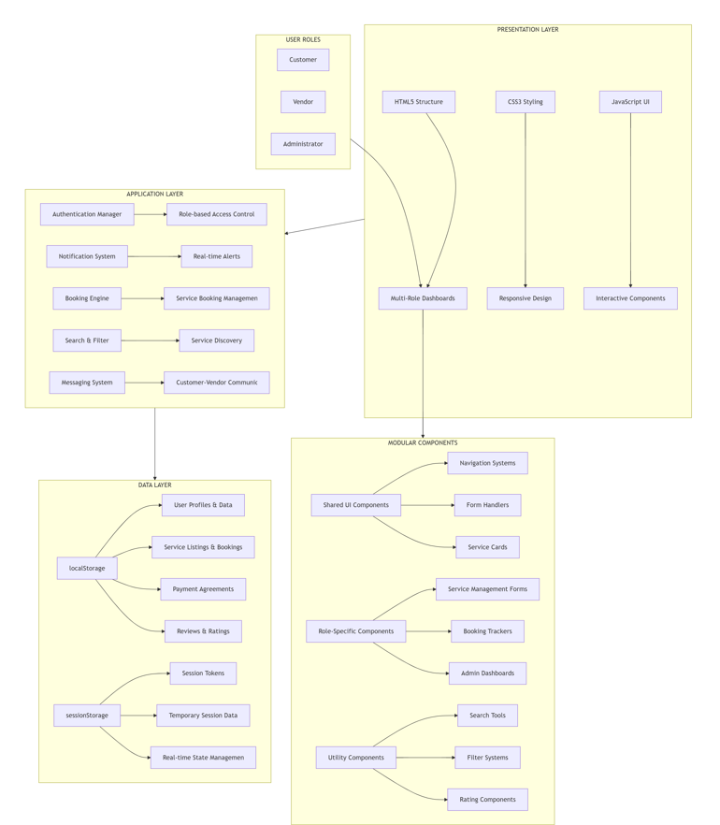

### 5.1 Flow Chart:

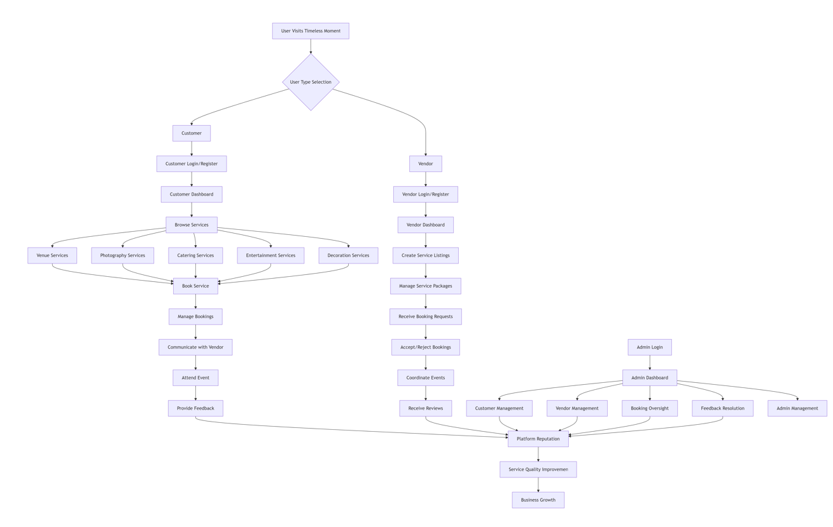

**Fig. demonstration of the website**

## CHAPTER - 6

**CODING ANALYSIS AND RESULTS**

### Code:

**i. Index file:**

<!DOCTYPE html>

<html lang="en">

<head>

  <meta charset="UTF-8">

  <meta name="viewport" content="width=device-width, initial-scale=1.0">

  <title>Timeless Moments - Home</title>

  <style>

    :root {

      --light-blue: #e1f5fe;

      --light-pink: #fce4ec;

      --light-purple: #f3e5f5;

      --medium-blue: #81d4fa;

      --medium-pink: #f8bbd9;

      --medium-purple: #e1bee7;

      --dark-blue: #0288d1;

      --dark-pink: #f06292;

      --dark-purple: #8b5cf6;

    }

    * {

      margin: 0;

      padding: 0;

      box-sizing: border-box;

      font-family: 'Segoe UI', Tahoma, Geneva, Verdana, sans-serif;

    }

    body {

      background-image: url('event1.avif');

      background-size: cover;

      background-position: center;

      background-attachment: fixed;

      background-repeat: no-repeat;

      min-height: 100vh;

      color: white;

    }

    header {

      background: linear-gradient(135deg, var(--medium-blue), var(--medium-pink), var(--medium-purple));

      padding: 20px 0;

      box-shadow: 0 4px 12px rgba(0,0,0,0.1);

    }

    .container {

      width: 90%;

      max-width: 1200px;

      margin: 0 auto;

    }

    .header-content {

      display: flex;

      justify-content: space-between;

      align-items: center;

      flex-wrap: wrap;

    }

    .logo h1 {

      color: white;

      font-size: 32px;

      text-shadow: 2px 2px 4px rgba(0,0,0,0.2);

    }

    .logo p {

      color: white;

      font-size: 14px;

      opacity: 0.9;

    }

    nav ul {

      display: flex;

      list-style: none;

      flex-wrap: wrap;

    }

    nav ul li {

      margin-left: 25px;

    }

    nav ul li a {

      color: white;

      text-decoration: none;

      font-weight: 500;

      padding: 8px 15px;

      border-radius: 20px;

      transition: all 0.3s ease;

    }

    nav ul li a:hover {

      background: rgba(255,255,255,0.2);

    }

    .hero {

      text-align: center;

      padding: 80px 0;

      background: rgba(255,255,255,0.7);

      margin: 30px 0;

      border-radius: 20px;

      box-shadow: 0 10px 25px rgba(0,0,0,0.1);

    }

    .hero h2 {

      font-size: 42px;

      color: var(--dark-purple);

      margin-bottom: 20px;

    }

    .hero p {

      font-size: 20px;

      color: #555;

      max-width: 800px;

      margin: 0 auto 30px;

    }

    .cta-buttons {

      display: flex;

      justify-content: center;

      gap: 20px;

      margin-top: 30px;

      flex-wrap: wrap;

    }

    .btn {

      padding: 14px 30px;

      border-radius: 30px;

      text-decoration: none;

      font-weight: 600;

      transition: all 0.3s ease;

      display: inline-block;

    }

    .btn-primary {

      background: linear-gradient(135deg, var(--medium-blue), var(--medium-pink), var(--medium-purple));

      color: white;

      box-shadow: 0 5px 15px rgba(0,0,0,0.1);

    }

    .btn-primary:hover {

      transform: translateY(-3px);

      box-shadow: 0 8px 20px rgba(0,0,0,0.15);

    }

    .btn-secondary {

      background: white;

      color: var(--dark-purple);

      border: 2px solid var(--medium-purple);

    }

    .btn-secondary:hover {

      background: var(--light-purple);

    }

    footer {

      background: linear-gradient(135deg, var(--medium-blue), var(--medium-pink), var(--medium-purple));

      color: white;

      padding: 40px 0;

      text-align: center;

      margin-top: 60px;

    }

    .footer-links {

      display: flex;

      justify-content: center;

      gap: 30px;

      margin: 20px 0;

      flex-wrap: wrap;

    }

    .footer-links a {

      color: white;

      text-decoration: none;

      transition: opacity 0.3s ease;

    }

    .footer-links a:hover {

      opacity: 0.8;

    }

    .copyright {

      margin-top: 20px;

      opacity: 0.8;

    }

    @media (max-width: 768px) {

      .hero h2 { font-size: 32px; }

    }

  </style>

</head>

<body>

  <header>

    <div class="container">

      <div class="header-content">

        <div class="logo">

          <h1>Timeless Moments</h1>

          <p>Where Stories Begin – Book All Event Services in One Place</p>

        </div>

        <nav>

          <ul>

            <li><a href="services.html">Services</a></li>

            <li><a href="login-form-list-in-homepage.html">Login</a></li>

            <li><a href="feedback-form.html">Feedback</a></li>

            <li><a href="about.html">About</a></li>

          </ul>

        </nav>

      </div>

    </div>

  </header>

  <div class="container">

    <section class="hero">

      <h2>Create Unforgettable Events</h2>

      <p>From intimate gatherings to grand celebrations, we bring your vision to life with our comprehensive event services.</p>

      <div class="cta-buttons">

        <a href="register-form-list-in-homepage.html" class="btn btn-secondary">Get Started</a>

      </div>

    </section>

  </div>

  <footer>

    <div class="container">

      <div class="logo">

        <h1>Timeless Moments</h1>

        <p>Where Stories Begin – Book All Event Services in One Place</p>

      </div>

      <div class="footer-links">

        <a href="services.html">Services</a>

        <a href="login-form-list-in-homepage.html">Login</a>

        <a href="feedback-form.html">Feedback</a>

        <a href="about.html">About</a>

      </div>

      <div class="copyright">

        &copy; 2025 Timeless Moments. All rights reserved.

      </div>

    </div>

  </footer>

</body>

</html>

### Login Page:

<!DOCTYPE html>

<html lang="en">

<head>

    <meta charset="UTF-8">

    <meta name="viewport" content="width=device-width, initial-scale=1.0">

    <title>Customer Login - Timeless Moments</title>

    <link rel="stylesheet" href="css/customer-login.css">

</head>

<body>

    <div class="header">

        <h1>Timeless Moments</h1>

        <p>Customer Login</p>

    </div>

    <div class="form-container">

        <h2>Customer Login</h2>

        <form id="loginForm">

            <div class="form-group">

                <label>Email</label>

                <input type="email" id="email" required>

            </div>

            <div class="form-group">

                <label>Password</label>

                <input type="password" id="password" required>

            </div>

            <div class="error-message" id="errorMessage" style="display: none;">

                Invalid email or password!

            </div>

            <div class="divider"></div>

            <button type="submit" class="submit-btn">Login</button>

            <div class="links">

                <a href="customer-forget-password.html">Forgot Password?</a>

                <a href="customer-register.html">Don't have an account? Register</a>

            </div>

        </form>

    </div>

    <!-- Popup -->

    <div class="popup" id="popup">

        <div class="popup-content">

            <h2>✅ Login Successful!</h2>

            <p>Welcome back to Timeless Moments!</p>

            <button onclick="redirectToDashboard()">Continue</button>

        </div>

    </div>

    <script>

        document.getElementById('loginForm').addEventListener('submit', function(e) {

            e.preventDefault();

            const email = document.getElementById('email').value;

            const password = document.getElementById('password').value;

            const errorMessage = document.getElementById('errorMessage');

            const popup = document.getElementById('popup');

            // Hide previous error message

            errorMessage.style.display = 'none';

            // Get users from localStorage

            const users = JSON.parse(localStorage.getItem('users')) || [];

            // Find user with matching email and password

            const user = users.find(u => u.email === email && u.password === password);

            if (user) {

                // Login successful

                // Store current user session

                localStorage.setItem('currentUser', JSON.stringify(user));

                // Show success popup

                popup.style.display = 'flex';

                // Redirect after 2 seconds

                setTimeout(() => {

                    window.location.href = "customer-dashboard.html";

                }, 2000);

            } else {

                // Login failed

                errorMessage.style.display = 'block';

            }

        });

        function redirectToDashboard() {

            window.location.href = "customer-dashboard.html";

        }

    </script>

</body>

</html>

### Admin Login Page:

<!DOCTYPE html>

<html lang="en">

<head>

    <meta charset="UTF-8">

    <meta name="viewport" content="width=device-width, initial-scale=1.0">

    <title>Admin Login - Timeless Moments</title>

    <style>

        :root {

            --light-blue: #e1f5fe;

            --light-pink: #fce4ec;

            --light-purple: #f3e5f5;

            --medium-blue: #81d4fa;

            --medium-pink: #f8bbd9;

            --medium-purple: #e1bee7;

            --dark-blue: #0288d1;

            --dark-pink: #f06292;

            --dark-purple: #8b5cf6;

        }

        * {

            margin: 0;

            padding: 0;

            box-sizing: border-box;

            font-family: 'Segoe UI', Tahoma, Geneva, Verdana, sans-serif;

        }

        body {

            background: linear-gradient(135deg, var(--light-blue) 0%, var(--light-pink) 50%, var(--light-purple) 100%);

            min-height: 100vh;

            padding: 20px;

            display: flex;

            flex-direction: column;

            align-items: center;

            justify-content: center;

        }

        .header {

            text-align: center;

            margin-bottom: 30px;

            width: 100%;

        }

        .header h1 {

            color: var(--dark-purple);

            font-size: 36px;

            margin-bottom: 10px;

            text-shadow: 2px 2px 4px rgba(0,0,0,0.1);

        }

        .header p {

            color: #555;

            font-size: 18px;

            max-width: 800px;

            margin: 0 auto;

        }

        .form-container {

            background-color: white;

            border-radius: 15px;

            box-shadow: 0 10px 25px rgba(0, 0, 0, 0.1);

            padding: 30px;

            width: 100%;

            max-width: 500px;

            animation: fadeIn 0.5s ease-in-out;

        }

        h2 {

            color: var(--dark-blue);

            margin-bottom: 25px;

            text-align: center;

            font-size: 28px;

            border-bottom: 2px solid var(--light-blue);

            padding-bottom: 10px;

        }

        .form-group {

            margin-bottom: 20px;

        }

        label {

            display: block;

            margin-bottom: 8px;

            color: #555;

            font-weight: 500;

        }

        input {

            width: 100%;

            padding: 12px 15px;

            border: 2px solid var(--light-blue);

            border-radius: 8px;

            font-size: 16px;

            transition: all 0.3s ease;

            outline: none;

        }

        input:focus {

            border-color: var(--medium-blue);

            box-shadow: 0 0 0 3px rgba(129, 212, 250, 0.3);

        }

        .divider {

            height: 1px;

            background: linear-gradient(to right, transparent, var(--light-blue), var(--light-pink), var(--light-purple), transparent);

            margin: 25px 0;

        }

        .submit-btn {

            background: linear-gradient(to right, var(--medium-blue), var(--medium-pink), var(--medium-purple));

            color: white;

            border: none;

            padding: 14px 20px;

            border-radius: 8px;

            font-size: 16px;

            font-weight: 600;

            cursor: pointer;

            width: 100%;

            transition: all 0.3s ease;

            margin-top: 10px;

        }

        .submit-btn:hover {

            transform: translateY(-2px);

            box-shadow: 0 5px 15px rgba(0, 0, 0, 0.1);

        }

        .links {

            display: flex;

            justify-content: space-between;

            margin-top: 15px;

            flex-wrap: wrap;

        }

        .links a {

            text-decoration: none;

            color: var(--dark-blue);

            font-size: 14px;

            transition: color 0.3s ease;

        }

        .links a:hover {

            color: var(--dark-pink);

        }

        .popup {

            display: none;

            position: fixed;

            top: 0;

            left: 0;

            width: 100%;

            height: 100%;

            background: rgba(0,0,0,0.6);

            justify-content: center;

            align-items: center;

            z-index: 1000;

        }

        .popup-content {

            background: #fff;

            padding: 30px;

            border-radius: 15px;

            text-align: center;

            width: 380px;

            box-shadow: 0 10px 20px rgba(0,0,0,0.25);

            animation: scaleIn 0.4s ease-in-out;

        }

        .popup-content h2 {

            color: #16a34a;

            margin-bottom: 15px;

        }

        .popup-content p {

            color: #555;

            margin-bottom: 15px;

        }

        .loading-bar {

            width: 100%;

            height: 6px;

            background: #e0e0e0;

            border-radius: 3px;

            margin: 20px 0;

            overflow: hidden;

        }

        .loading-progress {

            height: 100%;

            width: 0%;

            background: linear-gradient(to right, var(--medium-blue), var(--medium-purple));

            border-radius: 3px;

            animation: loading 2s ease-in-out forwards;

        }

        @keyframes fadeIn {

            from { opacity: 0; }

            to { opacity: 1; }

        }

        @keyframes scaleIn {

            from { transform: scale(0.8); opacity: 0; }

            to { transform: scale(1); opacity: 1; }

        }

        @keyframes loading {

            from { width: 0%; }

            to { width: 100%; }

        }

        @media (max-width: 768px) {

            .links {

                flex-direction: column;

                gap: 10px;

                align-items: center;

            }

        }

    </style>

</head>

<body>

    <div class="header">

        <h1>Timeless Moments</h1>

        <p>Admin Login</p>

    </div>

    <div class="form-container">

        <h2>Admin Login</h2>

        <form onsubmit="showPopup(event)">

            <div class="form-group">

                <label>Email</label>

                <input type="email" required>

            </div>

            <div class="form-group">

                <label>Password</label>

                <input type="password" required>

            </div>

            <div class="divider"></div>

            <button type="submit" class="submit-btn">Login</button>

            <div class="links">

                <a href="admin-forget-password.html">Forgot Password?</a>

            </div>

        </form>

    </div>

    <!-- Popup -->

    <div class="popup" id="popup">

        <div class="popup-content">

            <h2>✅ Login Successful!</h2>

            <p>Welcome back to Timeless Moments Admin Panel!</p>

            <p>Redirecting to Admin Dashboard...</p>

            <div class="loading-bar">

                <div class="loading-progress"></div>

            </div>

        </div>

    </div>

    <script>

        // Show popup on form submission and redirect to admin dashboard

        function showPopup(e) {

            e.preventDefault();

            document.getElementById('popup').style.display = 'flex';

            // Redirect to admin dashboard after 2 seconds

            setTimeout(() => {

                window.location.href = 'admin dashboard.html';

            }, 2000);

        }

    </script>

</body>

</html>

### 6.2 Result:

1. **Home Page :**Your premier destination for seamless event planning, connecting you with trusted vendors and comprehensive services to bring your special occasions to life effortlessly**.**

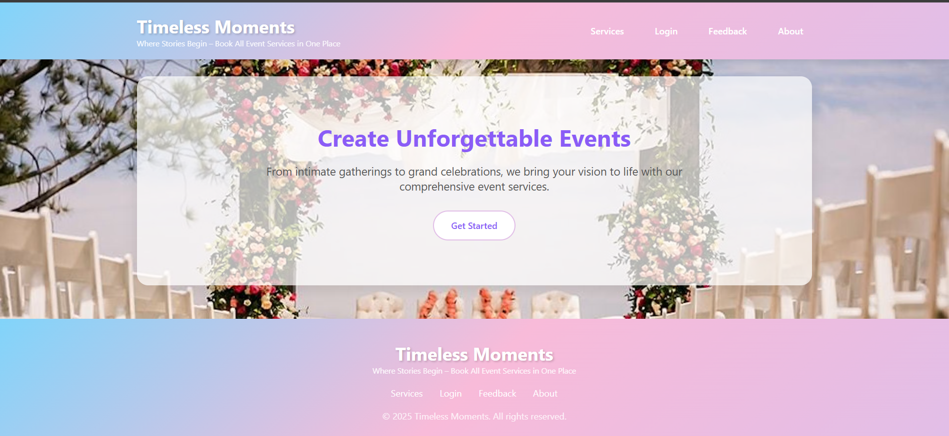

### Types of registration:

This is the registration page where users select their role as either vendor or customer to proceed with account creation. The interface provides clear descriptions of each role's capabilities and guides users toward the appropriate registration path.

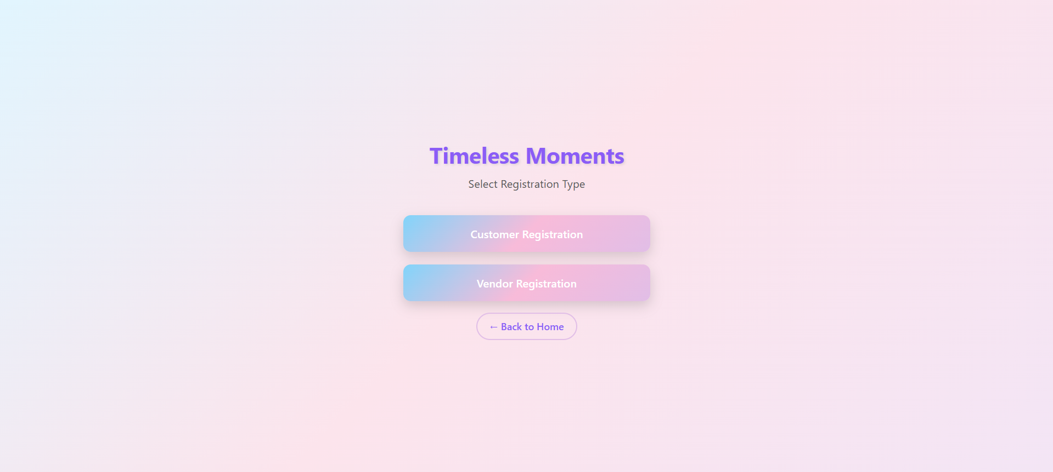

### Vendor Registration Page:

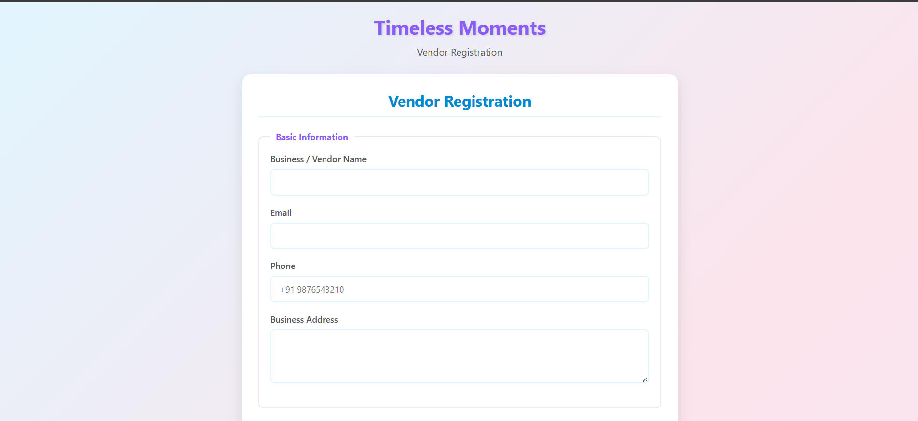

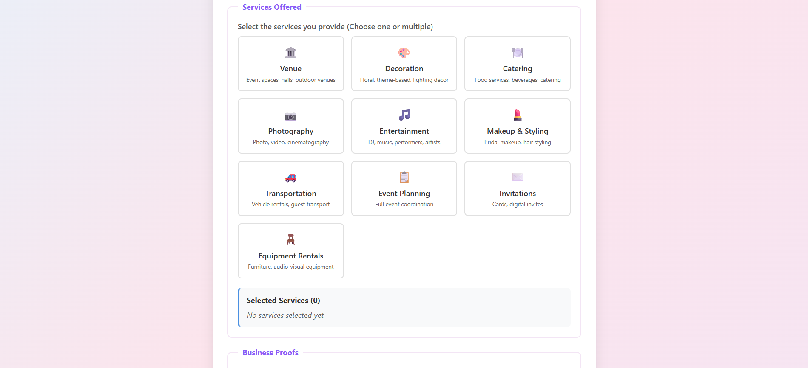

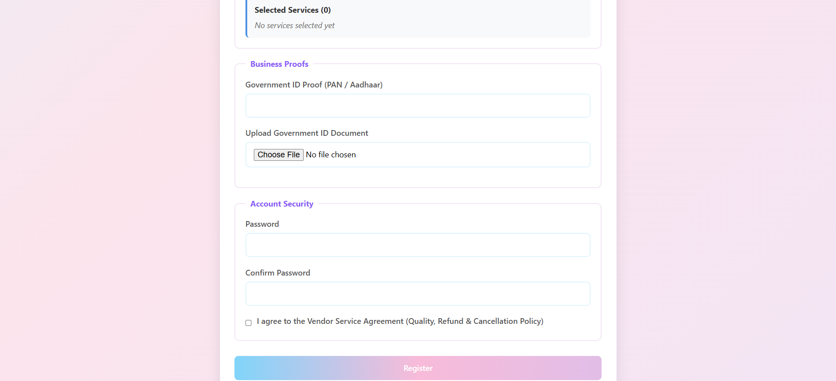

### Customer Login Page:

This page is customer login form where customers login to their accounts and book their services .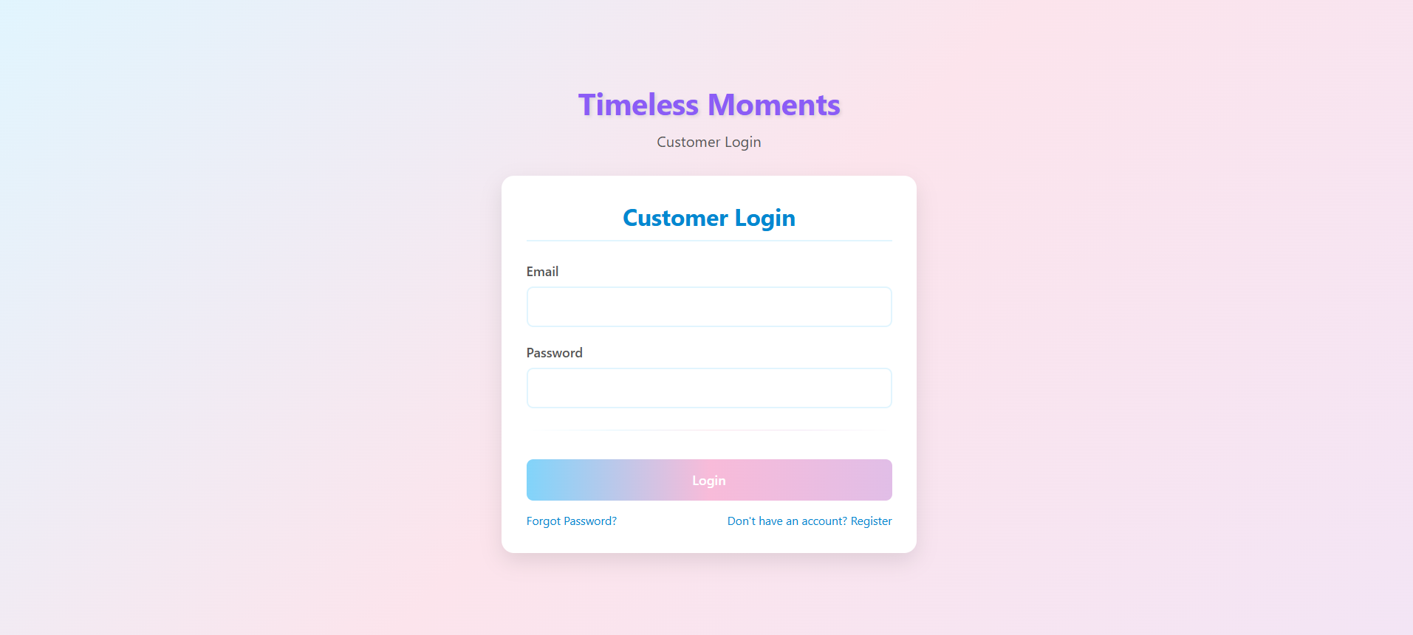

### Admin Login Page:

### Admin login page is used for only the persons who manage the platform and make the website easier to maintain and handle the issues of customers and vendors

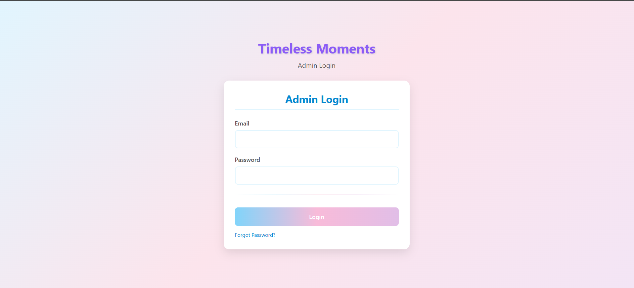

### Admin Dashboard:

The admin dashboard provides comprehensive platform oversight with modules for user management, vendor verification, booking monitoring, and system analytics. It features real-time statistics, dispute resolution tools, and comprehensive controls for maintaining platform quality and performance. 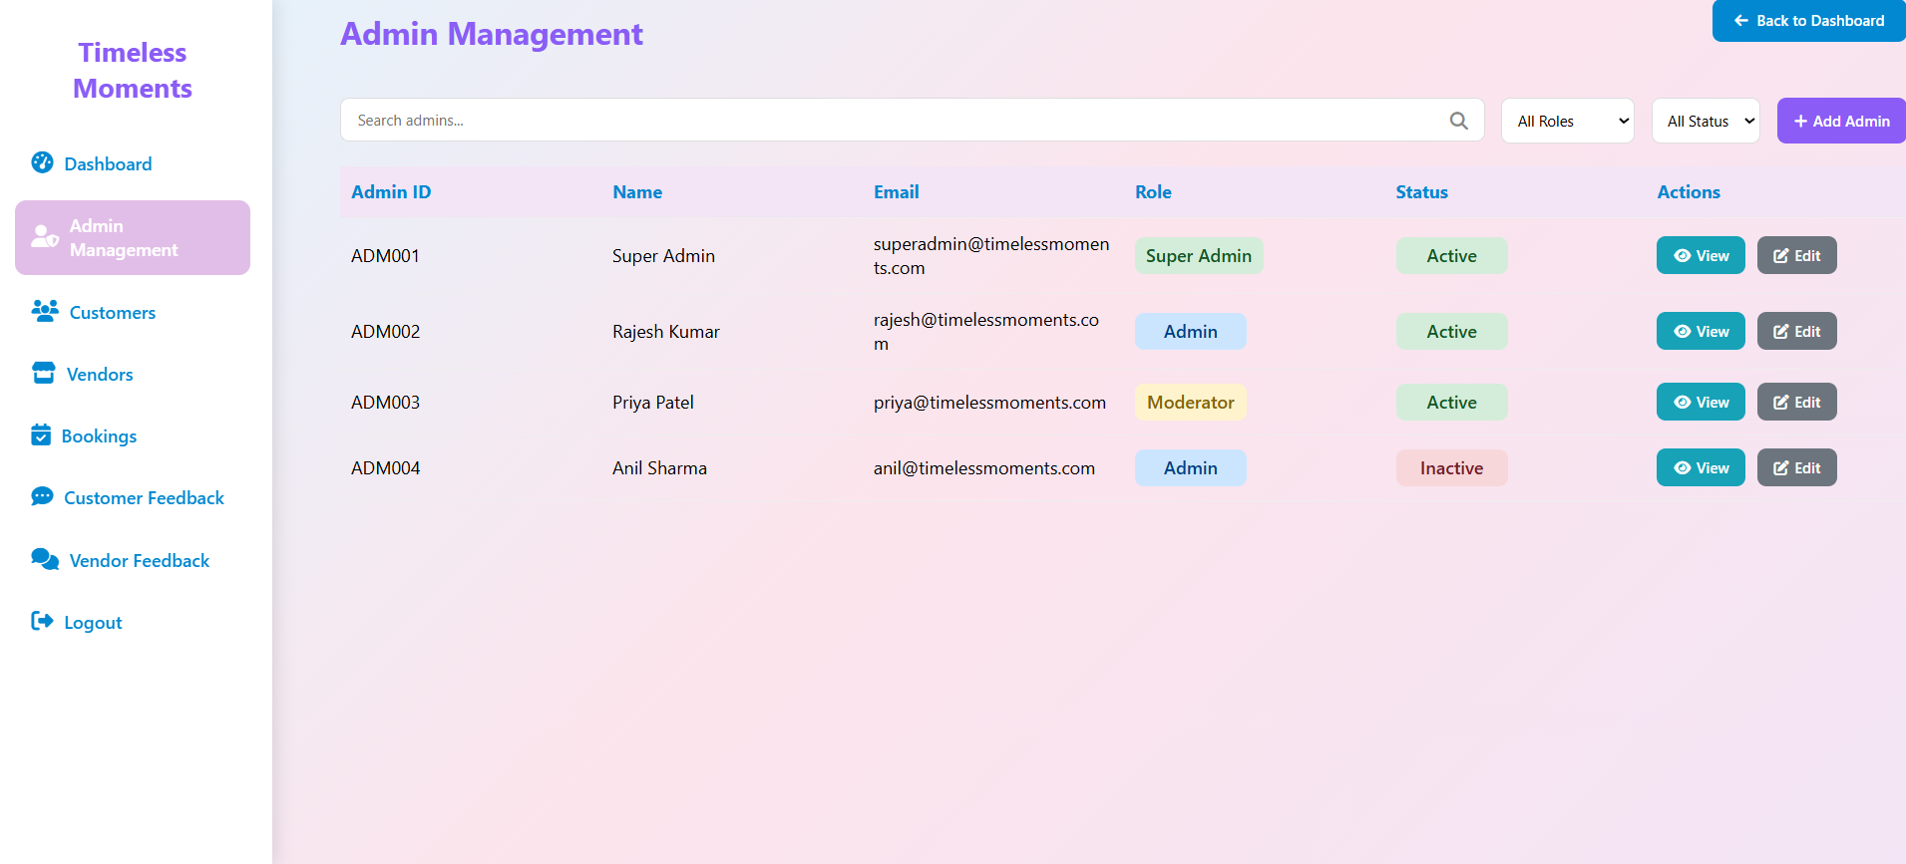

### Vendor Dashboard:

### The vendor dashboard provides complete business management with modules for service portfolio, booking requests, customer communications, and performance analytics. It features real-time notifications, package customization, and tools for growing your event service business.

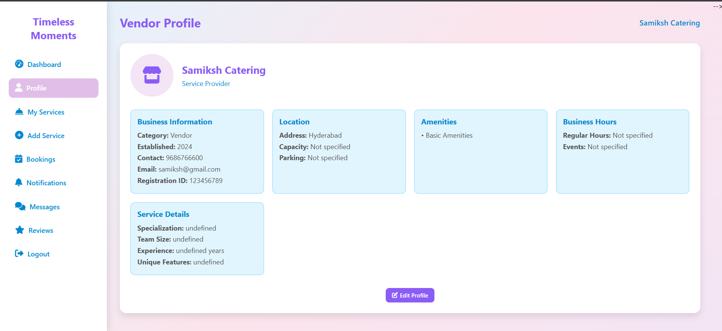

### viii. Customer Dashboard :

The customer dashboard offers seamless event planning with modules for service discovery, booking management, vendor communications, and event tracking. It features personalized recommendations, real-time updates, and tools for creating memorable events effortlessly.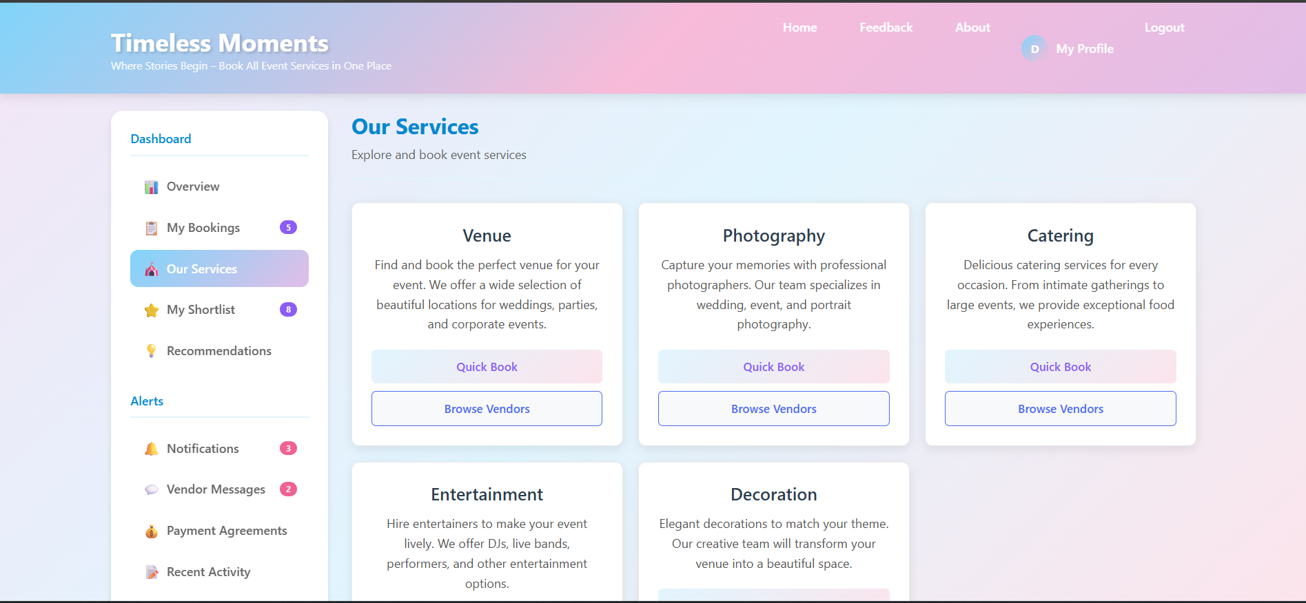

### ix. Services page in customer dashboard :

This page is used for cutomers to book their services by comparing the prices by clicking on view packages and they can also add to shortlist the services which they like .

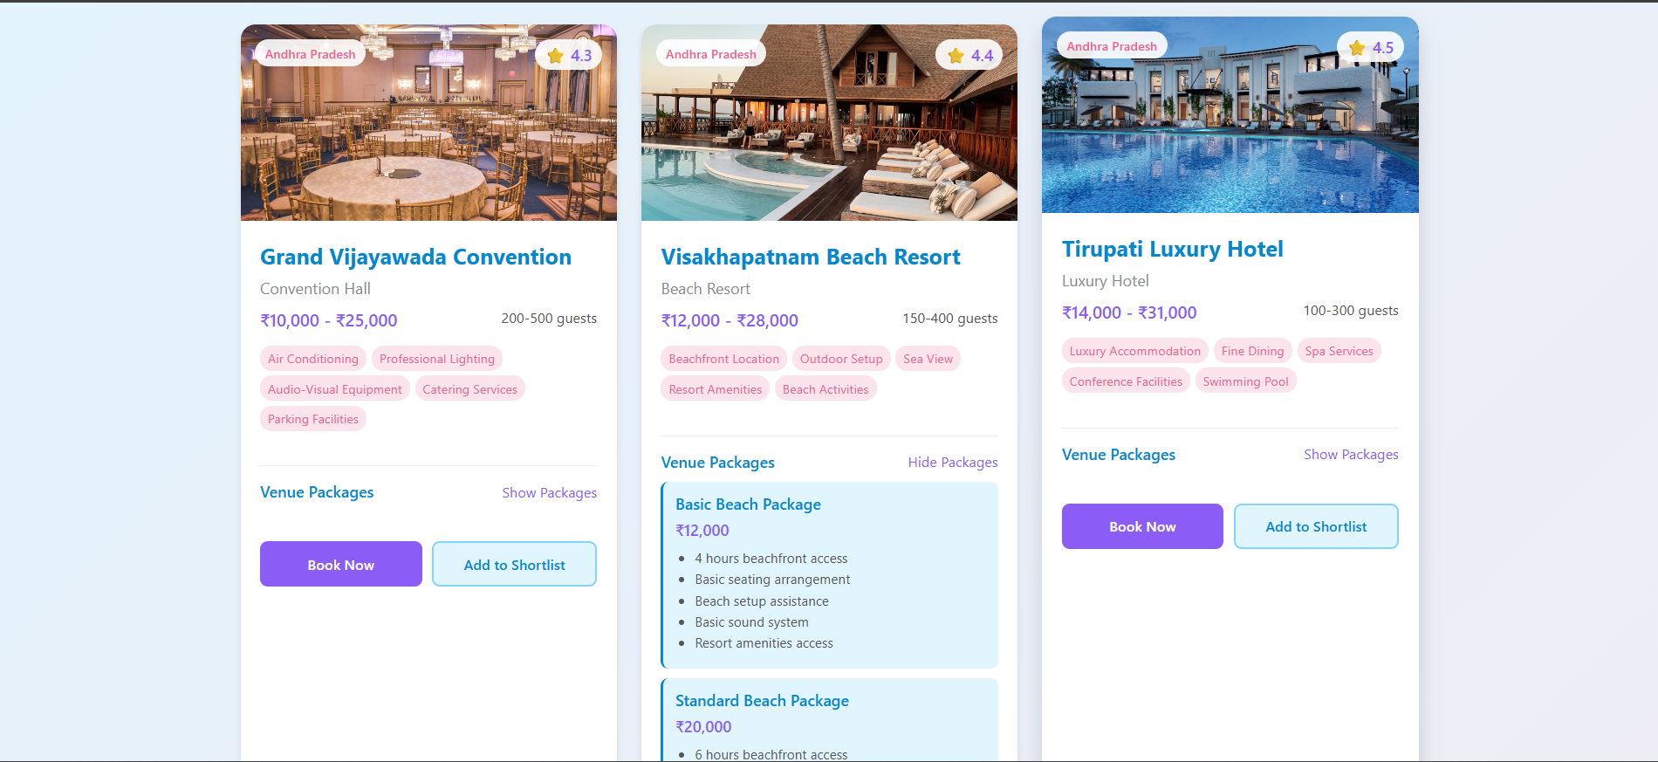

### x.Add services form in vendor dashboard :

### The Add Services form in the vendor dashboard provides comprehensive service creation with modules for basic information, package customization, pricing setup, and media uploads. It features dynamic form sections, real-time preview, and tools for creating attractive service listings that stand out to customers.

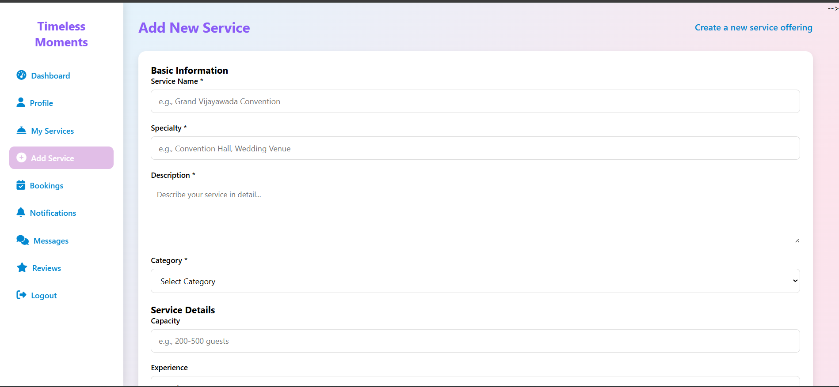

### xi. Feedback form:

The Customer Feedback Form provides comprehensive service evaluation with sections for ratings, detailed reviews, and issue reporting. It features intuitive star ratings, categorized feedback options, and tools for providing constructive feedback to improve vendor services.

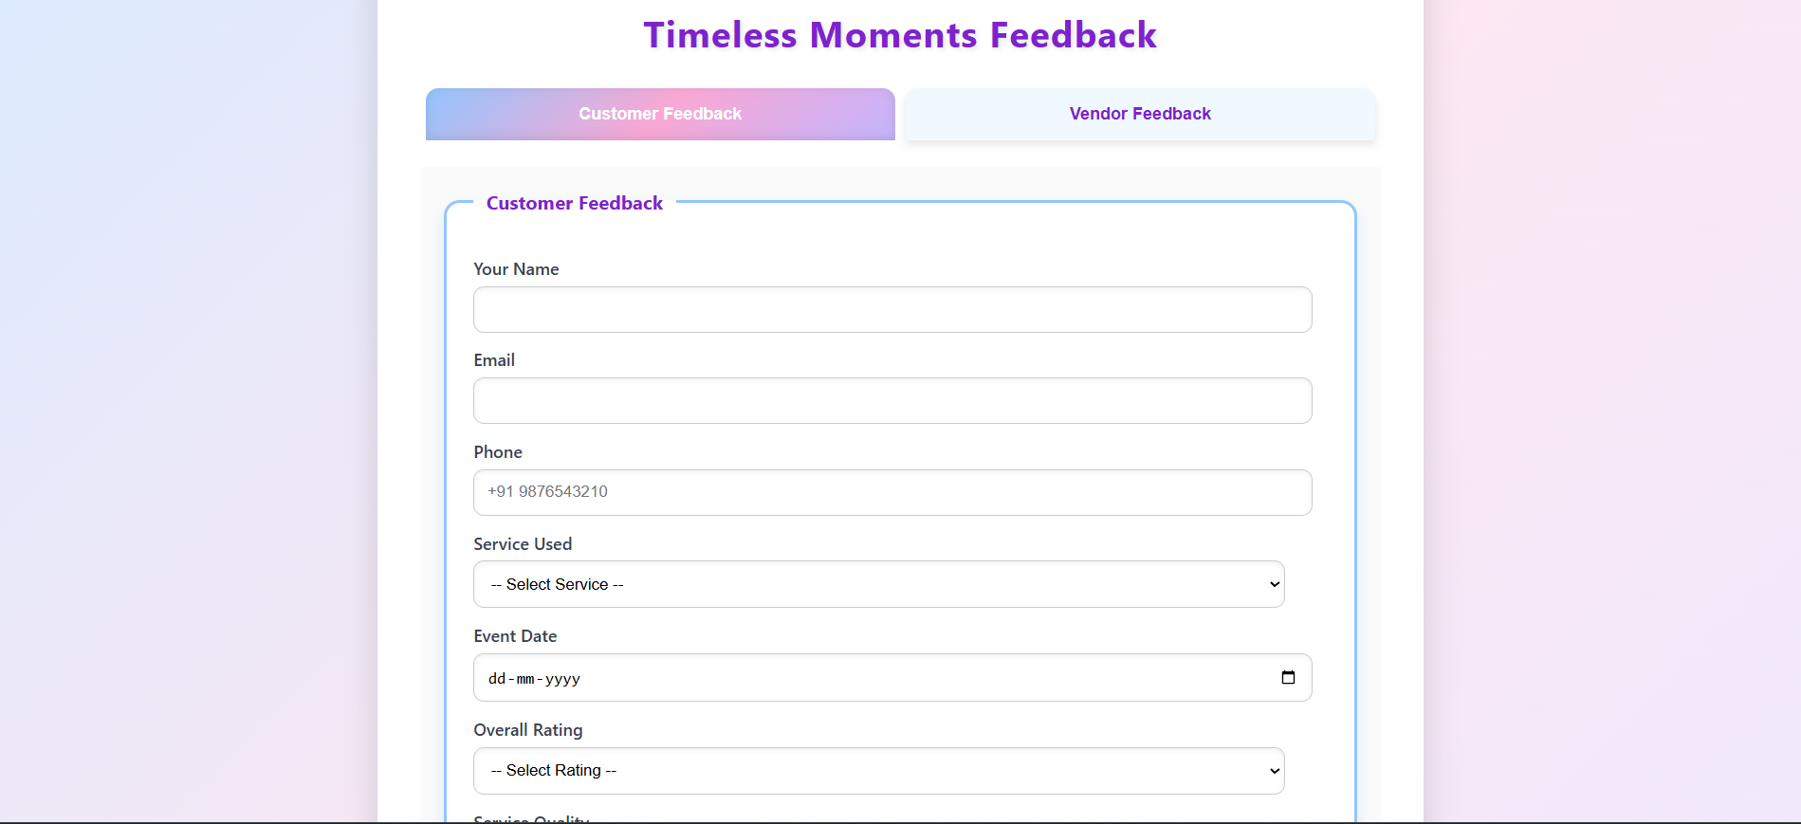

## CHAPTER-7 CONCLUSION AND FUTURE WORK

### Conclusion:

The Timeless Moments platform built using modern front-end technologies provides a comprehensive event management solution that effectively connects customers with professional event service vendors across diverse categories. With its intuitive multi-role design, comprehensive service management features, and seamless booking workflows, the platform offers an engaging and user-friendly experience for all stakeholders. The robust architecture supports complete event planning lifecycle management, from initial vendor discovery to post-event feedback, while maintaining scalability and performance across all user interactions.

The platform successfully addresses the critical need for a unified marketplace in the event services industry, bridging the gap between customers seeking reliable services and vendors looking to grow their business. Through sophisticated dashboard interfaces, real-time communication tools, and advanced search capabilities, Timeless Moments demonstrates how technology can transform traditional event planning into an efficient, transparent, and accessible process for all participants.

The implementation showcases the effective use of HTML5, CSS3, and JavaScript in creating a responsive, feature-rich web application that serves the evolving needs of the event management ecosystem while providing a solid foundation for future enhancements and integrations.

### Future Work:

This project offers several opportunities for future work and enhancements. Potential areas for future development include:

**Platform Expansion and Enhancement**

* Expand service categories by adding specialized event services such as wedding planning, transportation, makeup artists, and technical equipment rentals
* Implement regional and city-specific service hubs to cater to local event markets and emerging service providers
* Develop premium vendor tiers with enhanced visibility and advanced business tools

**Advanced Technology Integration**

* Implement AI-powered recommendation engines for personalized vendor suggestions based on event type, budget, and customer preferences
* Develop mobile applications for iOS and Android platforms to enhance accessibility and on-the-go booking management
* Integrate augmented reality features for venue previews and virtual service demonstrations
* Implement AI chatbots for instant customer support and preliminary vendor matching

**Enhanced User Experience Features**

* Develop comprehensive event planning tools including budget calculators, guest list managers, and timeline creators
* Implement real-time availability tracking and instant booking confirmation systems
* Create collaborative planning features for group events and wedding planning teams
* Add video consultation capabilities for virtual vendor meetings and service demonstrations

**Community and Trust Building**

* Establish comprehensive vendor verification systems with background checks and quality certifications
* Develop a robust review and rating system with verified customer feedback
* Create community forums and knowledge bases for event planning advice and vendor discussions
* Implement dispute resolution mechanisms and customer protection policies

**Technical Advancements**

* Migrate to cloud-based architecture with real-time database synchronization
* Implement microservices architecture for improved scalability and maintenance
* Develop API integrations with calendar systems, mapping services, and social media platforms
* Add multilingual support to cater to diverse regional markets across India

**Market Expansion**

* Develop corporate event management features for business clients and enterprise accounts
* Create international expansion capabilities with multi-currency and multi-language support
* Implement partnership programs with event venues, hotels, and related service providers
* Develop white-label solutions for event management companies and venue operators